Working problem note:

1. Gray Fabric a vat hobe na (**0**)
2. Paid now option a RC payment system dite hobe. (accounts).
3. Stock Out (product entry Admin a system dite hobe)
4. Willing to Buy and Sell Report List a dite hobe. (1.SL No, 2. Name, 3. Mobile Number, 4. Email, 5. Product Buy (Buyer a) 6. Product Sell (Seller a) 7. Location, 8. WhatsApp Number
5. Invoice a – Sales Date hobe (Create Date a place a) Buyer er only Name thakbe address, phone hide hobe- Seller Invoice a, payment status Paining thakbe. SSL sslcommerz keno.
6. Total number of Product Showing (website a dite hobe)
7. Seller Registration er somoi NID/Trade ja dibe sob Employer a o chole asbe auto again fill up na korte hoi.
8. Seller/Buyer/Job/Work Order, Product Entry, Buy Request All Place a Date, hour, Minute, Second – Avabe dite hobe.
9. Invoice Date Wise + Sales + Revenue te Same Date a hobe.
10. Invoice a Product Image dite hobe. Invoice download Option korle Invoice number soho download name soho diben.
11. Admin er Dashboard Only Super Admin dekbe onno admin role hide kore diben.
12. Admin login a Rong password dile OTP na jai Right ta dile OTP jabe only.
13. Payment er Description ja like seta Invoice a dite hobe.
14. Payment Paid kon Admin Role thake korche seta commission list a dite hobe.
15. **Admin Role Permission** – Seller (Profile view only, Not Verification, Not Edit, Not Delete) (Product Entry – Only View, Not Edit, Not Delete) (Old work problem)

* Buyer – (Profile view only, No Verification, No Edit, No Delete)
* (Buyer Requested Product - Only View, Not Edit, Not Delete)
* And Ami Role a 200 Data List Or January Fixed Kore dibo ar onno list view korte parbe na avabe admin Role dite hobe

1. Dashboard + Visitor Only Super Admin dekbe but admin onnano Role thake off thakbe now dekte parche off kore din.
2. Apply for Seller a – Company name English & Company Name Bangla

J mode a thakbe 1 ta Box thakbe.

Same Company Address o 1 ta Box thakbe.

1. Fabric er Product Vat Different type ase. Kon Fabric a koto vat amra List diye dibo se onujaye Vat boshaite hobe.

16. Product All category te – Sort By te

- Country wise short searh

- Company wise short search দিতে হবে।

1. Registration a mobile country code change korle country name search kora jai na scroll kore khuje nite hoi. Search option dite hobe.
2. NID / Photo ID এর উপর pop up back line যাবে যে “Authentication purpose need this NID”
3. Willing to Buy + Sell Report List a dite hobe Seller Buyer er Category onujaye.
4. Product wise + Email + Phone number report list. Seller/ Buyer.
5. Job Designation wise Email + Phone number report list.
6. Work Order a receiver & Provider এর Product wise/ search wise -Phone + Email Report List
7. Job / Work order/buyer/seller location wise report list.
8. News and blog a new article Hole. – Notification যাবে Yarn, fabric product দেখাবে
9. Fabric er All product Featured Product এ থাকবে।
10. Product Name wise এ যেন report আসে।
11. Willing to Sell/Buy এর ক্ষেত্রে full category আসবে যেন সে special product select করতে পারে।
12. NID/Photo ID থেকে auto notice দেয়ার ব্যবস্থা।
13. সব ধরণের Product wise যেন report পাবে like-T-shirt/Garments/Knit/Yarn/Cotton
14. Whatsapp number List report এ হবে।
15. Product Description দামের মায়েদ কাল থাকবে এবং মায়েদ কালের উপর Mouse রাখলে লিখা আসবে "কাঁচামালের দামের পরিবর্তন সাথে পণ্যের দামের পরিবর্তন হতে পারে। " এবং উপরে যে categories বর্ণনা তাহা দামদর নাই। যেন: fabric, cotton হবে।
16. Location Name (My Buying Location) Buyer Add করা যেতে পারে on Photo ID/NID থেকে নেয়া যেতে পারে।
17. App এর Whole Sale এর কোনো নাম নাই।
18. App Name Fabric but যায় না।
19. Fabric RMG বা যে Product গুলো আছে, সবগুলো আলাদা আলাদা থাকবে।
20. Fabric এর যায়গায় fabric RMG এর যায়গায় RMG বা kids এর যায়গায় kids item. Women Item এর যায়গায় Women's item. mens Item এর যায়গায় mens item যেটা যার প্রয়োজন সে সেটাতে click করে Product পেয়ে যাবে।
21. App আরো easy হওয়া প্রয়োজন।
22. Buyer commission invoice a commission ta bad jabe
23. Seller jokon product entry korbe Product Entry er amount er sathe VAT Auto price Add hobe. And EK ek ta Category vat alada hobe.
24. Seller er mail a mail jabe if Sell conform invoice number and payment id
25. Buyer Seller er Invoice a Corporate + Register Seller/Buyer er Address thakbe na only name thakbe (Amader Admin a Seller/Buyer er Corporate+register address thakbe)
26. Admin a Login korle Rong password dile jeno OTP na ase.
27. Fabric> Local > Denim > Raw er por er category gulo delete hobe. Inform korben when delete korben.
28. Job registration a Duration for Joining to New Job – 6 Month, 6 Month +add hobe.
29. Fabrics> Local> Woven Category তে কোনো প্রোডাক্ট পাওয়া যাচ্ছে না, আমরা নিউ category add korechi করেছি। Yarn >Woven >Gray er সাথে all Fabric>Local>Woven a add hobe all products.
30. Job registration Age 60+ add hobe.

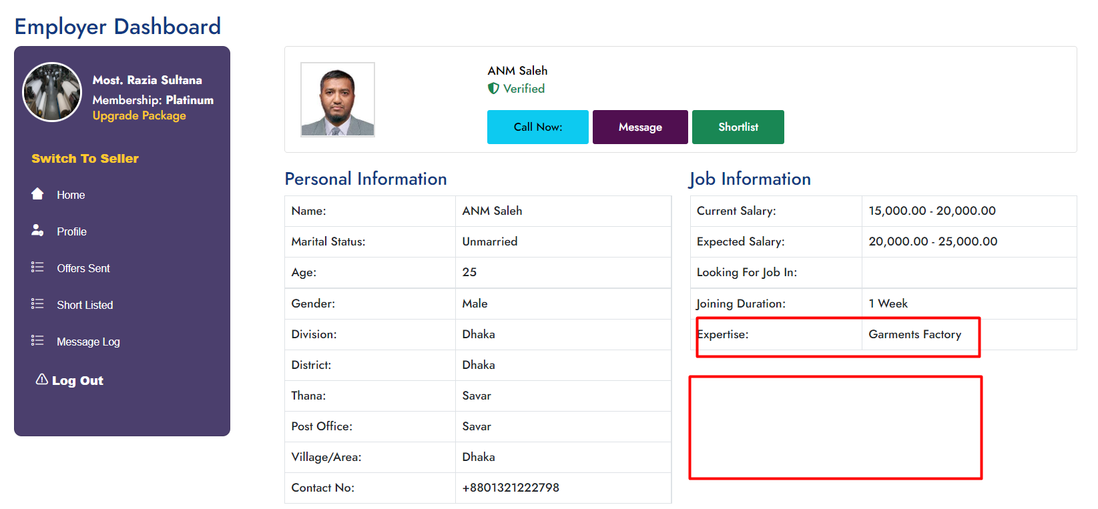

# Expertise - Garments Factory, Kint Factory, Assistant Manager (Sub Category, Employment type অ্যাড করবেন।

Education Bedground Show kore na.

# Job Experience, Company Name, Educational Qualification - শো করে না. Dekhate hobe agulo.

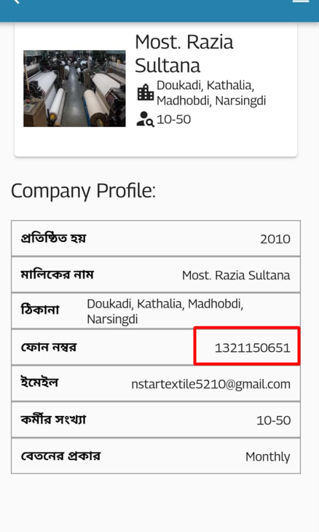

Company Details a company Number Hide kore diben

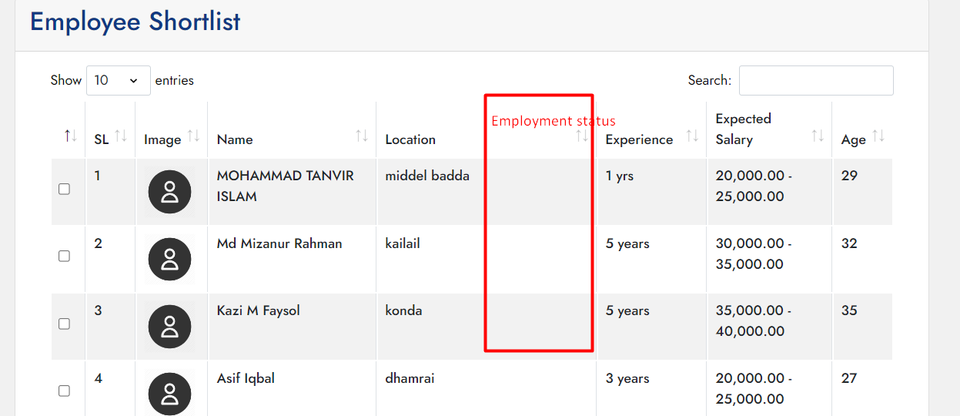

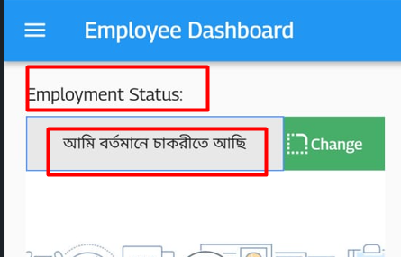

Employment status – Employee Shortlist a dite hobe.

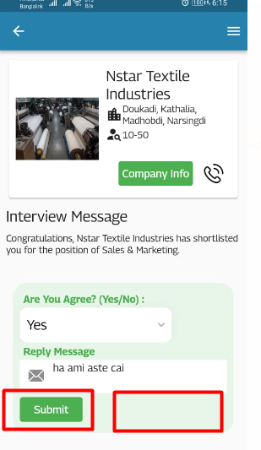SMS to company - Email to Company ২ তা বাক্স হবে, Direct কোম্পানি কে Massage এন্ড মেইল করতে পারবে।

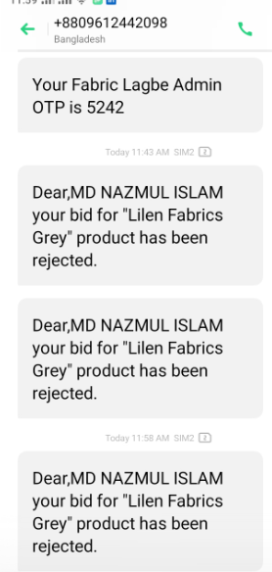

3 Bar Massage Asche Bid Reject Hoise. Bid Reject Name ta Change Hobe (Sold Out) or jeta vhalo hoi.

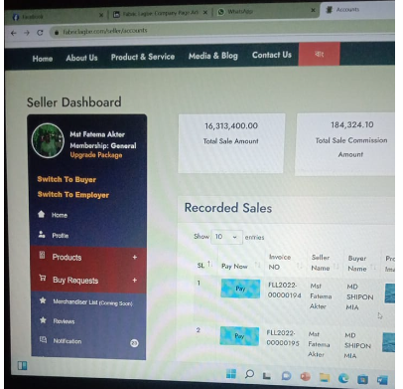

Product Bid **2 bar Accept hoise** dekhacche- 1 bar Dekhabe

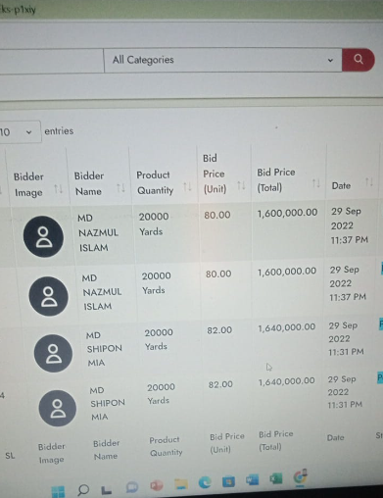

2 ta Product er Bid 2 bar kore hoise System a Problem ase Fix asap.